<https://docs.microsoft.com/ru-ru/cli/azure/install-azure-cli-apt?view=azure-cli-latest>

[https://docs.microsoft.com/ru-ru/azure/azure-functions/functions-run-local#v2](https://docs.microsoft.com/ru-ru/azure/azure-functions/functions-run-local" \l "v2)

Python



Azure-functions

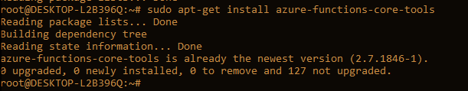

Az CLI

